Company Name
Benefits Map
[Type name of programme/project]
Place your company logo here

Insert name of document author
Select date

Page left intentionally blank

Document History

Owner:
Location:
Status

Revision History

Version | Revision Date | Change Summary | Author

Approvals and Sign-Off
This document requires approvals to be signed-off and released for live use

Version | Approved by | Position | Date

Distribution

Version | Distributed to | Date Issued

Page left intentionally blank

Table of Contents
1. Programme/Project ID 7
2. Benefit Map 7
3. Date of Next Review 7
4. Owner 7
Appendix – Benefits Map 8

Page left intentionally blank

Programme/Project ID
Insert the unique identifier for this programme/project.

Benefit Map
This is usually a graphical representation of the relationship between the deliverables of a project/project(s), the business changes (sometimes referred to as “capabilities”), the benefits and disbenefits that would result from the changes and, the strategic goals of the programme/project. Include the graphical representation as an Appendix.
Descriptions of each of these elements of the benefits map can be recorded under the following headings.
  - Project Deliverables
List of specific deliverables (or outputs) from the project(s).
  - Business Changes
A summary of the high-level business changes that will be enabled by the deliverables/outputs.
  - Benefits/Disbenefits
A list of the resulting benefits/disbenefits and their relationship to the business changes.
  - Strategic Goals
A list of the strategic goals that will be supported or contributed to by the business changes and the resulting benefits.

Date of Next Review
Insert the planned date of the next review.
The benefits map, like many aspects of a programme/project can be subject to many changes during the programme/project lifecycle. It is a dynamic support tool, to be used throughout the lifecycle and as such should be regularly revisited to ensure that the benefits map is up-to-date and aligned to business needs.

Owner
Name of the document owner – usually the Business Change Manager.

Appendix – Benefits Map
Capabilities (Outputs from Projects) | Benefits | Strategic Goals Supported
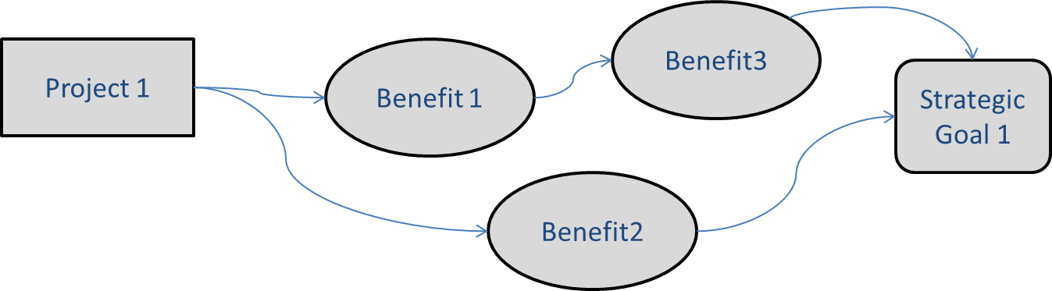  Include the projects that will deliver outputs that the business will use to generate new/improved business benefits | Include all of the benefits, including the ‘intermediate’ (sometimes referred to as ‘stepping stones’) and ‘end benefits’ that the project outputs will enable | Link the benefits to the strategic goals for your change programme or project

