Taking Service Forward (TSF)
- Governance and management of the Adaptive Service Model

Becoming a member
Everybody is encouraged to take part in the discussions in the open Google+, LinkedIn and Facebook groups as well as on Twitter to shape new elements or changes to the model.

To become a member of the Taking Service Forward (TSF) initiative you need to register with your e-mail address and agree to the copyright conditions on the TSF wiki (www.takingserviceforward.org). The creative commons license means that any contributions you make will become part of the model, free for other people to use and adapt. People who have contributed to the content will be acknowledged on the TSF web site.

Everybody can become a member of the initiative:
- Non-voting membership is granted to people who sign up to our copyright terms on the TSF wiki. These people have the right to access group collaboration areas of the wiki and to submit change requests
- Voting membership is granted to people who contribute to the development of the Adaptive Service Model, this is measured by the submission of approved change requests. These people have the right to vote on change requests and on other issues such as appointment of a new governance team

People will be moved from the voting-membership to non-voting membership if they don’t log in to the wiki for 6 months. A reminder will be sent before removal in case somebody still wishes to contribute. People may also be moved to non-voting membership, or even be removed from membership altogether, if in the opinion of the governance team they are disruptive to the smooth running of the community. This removal would be subject to appeal to the full set of voting members.

The list of voting members of Taking Service Forward will be published on the TSF wiki, with a link from the Copyright statement.

Governance
A thin layer of governance has been established to govern the Taking Service Forward initiative. It is recognized that while the overall intent is for the community to gain its value through open, collaborative crowd sourced activity, that a minimal set of rules is necessary.

The governance itself shall be open and accessible. Its scope is the model artifacts, their administration, communications to the community, the custodianship of the artifacts and any other matters relating to the Taking Service Forward initiative.

The initial governing body is a subset of the founding members of the Taking Service Forward initiative. The governance team consists of four voting members, and the governance team will be appointed yearly before July 1 by the voting members of TSF.

The responsibilities of the governance team include:
- Acting as change advisory board for changes to the Adaptive Service Model.
- Coordinating and managing the social channels in use for receiving and communicating the efforts of the crowd.
- Coordinating and managing the communication planning and execution for the purposes of:
  - ensuring the community is kept informed and involved in an effective and timely way of all community activities
  - providing an open, transparent means for members to provide feedback, and crowd source effort to the initiative.
- Custodianship of the artifacts. This may be delegated to some other group so long as the governance team retain overall governance.
- Liaising with associated organizations.
- Seeking member contributions to serve on ad-hoc or standing teams that the community wishes to create for the purposes of fulfilling the TSF vision and mission.

The governance model shall evolve with the initiative, with additional contributors to governance, management and administration of the model sought from among community members.

Management
The following schematic diagram illustrates the change management process for the adaptive service model (ASM).

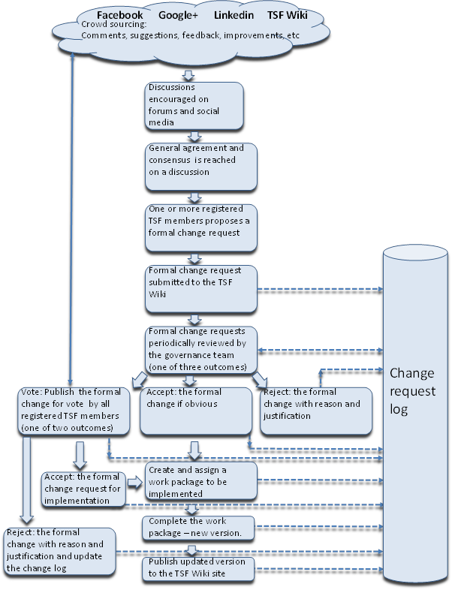

The steps in this change management process schematic diagram are explained in a bit more detail:

- The initial version of the ASM will be published on the taking service forward (TSF) Wiki website. Discussion on possible future changes will be encouraged in many different forums, including the TSF wiki, Google+, Facebook, LinkedIn, etc. If a specific topic is being discussed in more than one forum then the governance team may intervene to suggest moving this discussion to a single place.
- When discussion on a particular change reaches a point where it is suitable for submission, participants will be encouraged to submit a formal change request via the wiki. Formal change requests will only be accepted via the TSF wiki website, from registered TSF members.
- A formal change request may only be logged on the change request log within the TSF Wiki website, using the change request system.
- The change request log will be reviewed periodically by the TSF governance team. This will lead to one of three outcomes:
  - Voted: the change request will be put out to a vote of all current voting members of TSF.
  - Rejected: with a reason and justification, if there are very sound reasons which are non-controversial.
  - Accepted: if the change is simple and obvious, for example to correct an error or make a cosmetic change to improve a diagram
- If there are multiple change requests that overlap, duplicate or contradict each other then the governance team will work with the proposers of these changes to create one or more consolidated change requests that can be voted on by the voting members.
- If rejected either directly or as a result of member voting, the change request log will be updated containing details of all decisions, justifications and reasons for them. These will be accessible via the TSF wiki.
- If accepted the work package for the change will be created and assigned to an individual or group to be implemented. Changes will be incorporated into the model as soon as practical. It is not anticipated that multiple changes will be bundled into a single release unless there are good reasons (such as dependencies between the changes).
- The work package is completed and validated with a new version of the relevant ASM artefact(s) being created.
- The new version of the ASM artefact(s) are published on the TSF Wiki website

Once the change request has been raised, the change request log will be updated at each stage of the process to reflect the status of the change request.

It is expected that this process will need to be replaced when the ASM meta-model is complete and work starts on the model itself. At this time it is likely that there will need to be a more complex change management system with different areas of the model each having their own decision making team.

Further reading
Taking Service Forward - The charter
Taking Service Forward - The story
Taking Service Forward - The roadmap for the future

Adaptive Service Model - The context
Adaptive Service Model - High level diagram
Adaptive Service Model - Architecture concepts, modelling language and principles

Adaptive Service Model - Meta model - Diagram
Adaptive Service Model - Meta model - Objects and attributes

Connect with us
Web site
Document library
Google+ community
Facebook
Twitter
Twitter #tag
LinkedIn
LinkedIn group

Document Change Control

Revision Number | Date of Issue | Author(s) | Brief Description of Change
1 | Dec 30 2013 | Stuart Rance | Description of TSF membership
2 | Dec 30 2013 | Colin Rudd | Description of the change management process
3 | Jan 22 2014 | Christian F. Nissen | Document consolidated
4 | Feb 06 2014 | Stuart Rance | Feedback incorporated and comments resolved

